**If Consensus Not Achieved or you have 3 member group**

Individual Task (Only Technical Points Allowed)

Design (only 2 Pages)

1 Discuss in Your Own Words the MenuBased Design of your Assignment#2 Application. (i.e Discuss About Classes, Methods & DataMembers & Their Utilization to Achieve Application’s Goals in your radio button based application)

In our program, we have 2 basic entities - Account and Saving Account. Class Account has protected data members id, strName, accountType and balance. Class SavingAccount inherits Account class and has one more data member - rate.

For whole UI we developed class GUI with 3 radio buttons, 3 text fields and one push button. This class inherits from class JFrame, which is part of Java Swing library. In init method we initialize every necessary objects and attributes and create labels for radio buttons and for submit button. Aswell we initialize ActionListener for button and set heights and widths of GUI objects, as well as height and width of whole application window. Then we developed methods for fulfilling necessary functions as deleteByID, deleteByName, deleteByIndex and displayAll.

Main method is in UseSavingBankAccount class, which has static array for 50 SavingAccount objects and method initAccounts, which fills this array. Main method then just calls initAccounts method and set up GUI.

2 Discuss in Your Own Words Design of the Application After You have created your Menu based Application (i.e Discuss About Classes, Methods & DataMembers You Have Added & Their Utilization to Achieve Application’s Goals in your Menu Driven Application)

The design of the application is centered around the Account and SavingAccount classes. The GUI class is the main part for initialize all UI component, and each menu item will invoke the new dialog frame which respons for display all / convert / alter name panel. I also handle the empty input for each panel. I design the each function panel with its own method to deal with its specific function. The special part is the descending sort function in display all panel class, I use ArrayList and Comparable interface to do it.

3 Draw Class Diagram for Each Class You Have

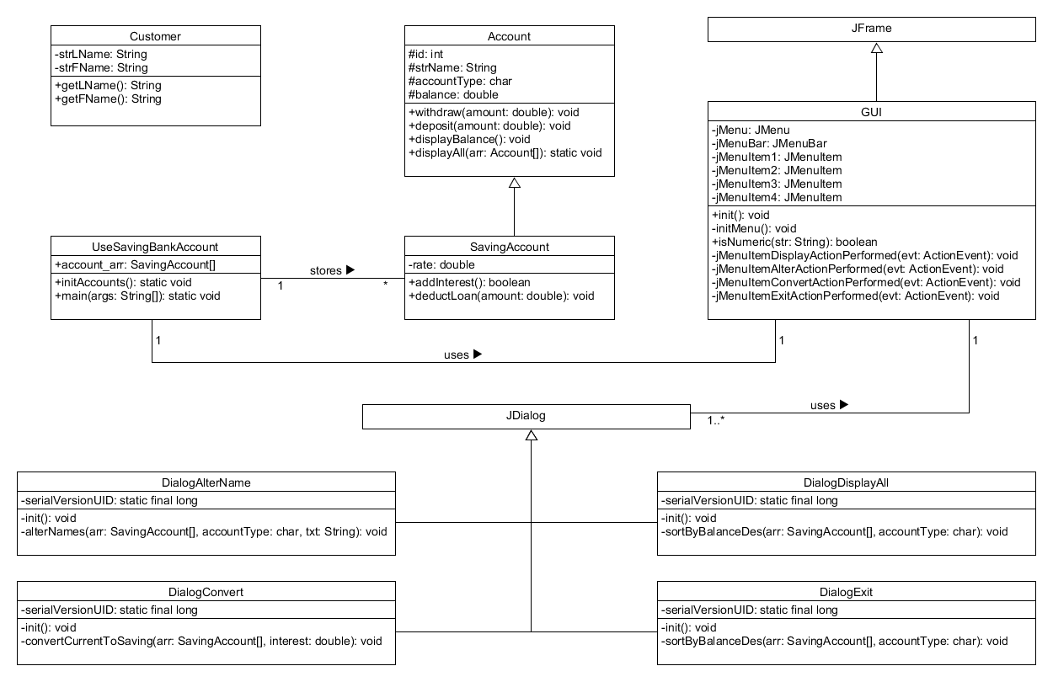

Discussion: (Only 1 Page)

Using Bottom Up Approach, create a design of your application as discussed in Lect#6

class **Account**{

int id, string strName, char accountType, double balance

}

**Account**(int id, String name, char type, double balance) {

this.id = id;

this.strName = name;

this.accountType = type;

this.balance = balance;  }

public void **withdraw**(double amount) {...}

public void **deposit**(double amount) {...}

public void **displayBalance**() {...}

public static void **displayAll**(Account[] arr) {...}

public class **SavingAccount extends Account** {

private double rate;

}

**SavingAccount**(int id, String name, char type, double balance, double rate) {

super(id,name,type,balance);

this.rate = rate;

}

public boolean **addInterest**(){...}

public void **deductLoan**(double amount){...}

public class **UseSavingBankAccount**{

public static SavingAccount account_arr[]; }

public static void **initAccounts**() {

account_arr = new SavingAccount[50];

for (int i=0;i<50;i++) {

account_arr[i] = new SavingAccount((i+1),"TTU"+(i+1),'C',0.0,5.0); }

public static void **main**(String[] args) {

initAccounts();

GUI gui = new GUI();}

Instead of Account and SavingsAccount Class, discuss any other inheritance based scenario which can be applied in this Course Assignment#2 & Project

A scenario that can be used in a similar way as the Account and SavingsAccount class, is a company roster and hour management. Company and CompanyHours will be the classes used. In the Company class you can build out the roster of employees as well as their ID numbers and pay rate that they have. In the CompanyHours portion you can use it as a way to log the amount of hours each employee has worked and give an output on which employees worked the most amount of hours sorted, How much a specific employee made that week, and list out a specific department’s employee based on ID arrangement.

In the context of 3, describe sub-parts of an Assignment#2 related question using your example of Base and Derive classes.

The Base class for Company would be Employee, EmployeeId, and Position while the base class for CompanyHours would be Time. The derive class for Employee would be Name, EmployeeId would be Department, and Position would be PayRate. For the Time base class, the derive class would be Hours,Minutes, and Seconds. Using these you will be able to build a profile for every employee that works for the company so that their name,department,Id, pay rate, and Time are completely documented.